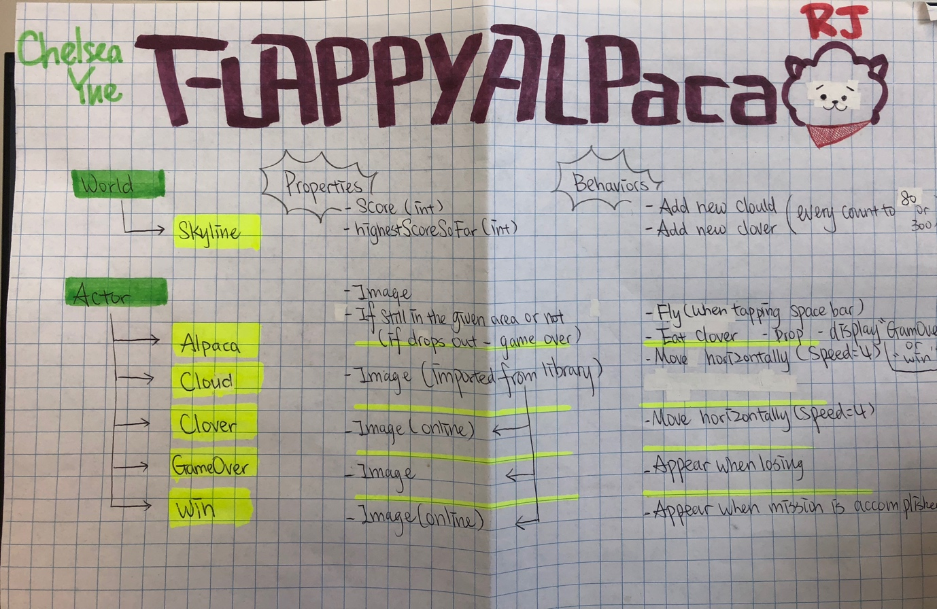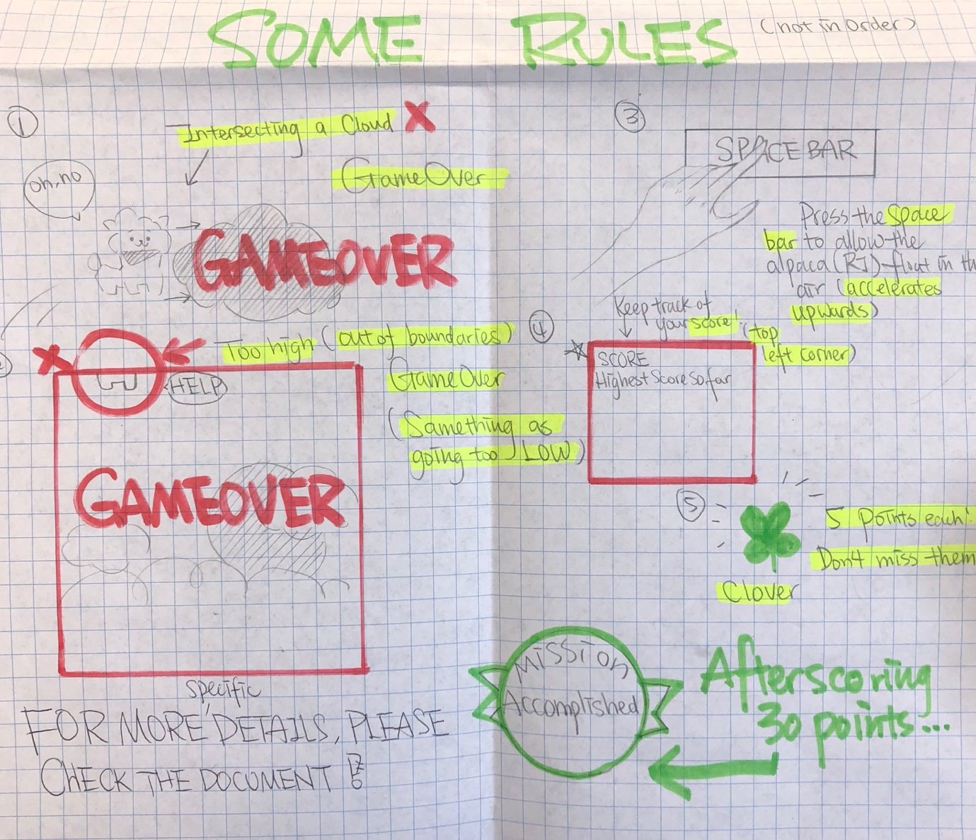

After 60 seconds

This game is called Flappy Alpaca, it’s typically designed for bored people and could improve hand-eye coordination while wiping away the boredom.

RJ —— the main character of this game, is an unique alpaca who can fly. He has numerous missions to complete within a day, if he fails, the entire earth will be in danger. Therefore, as the person who determines his destiny, you will be in charge of pressing the space bar once his mission begins, which allows RJ to float up in the sky. Once you stop pressing space bar, RJ will be pulled down by the gravity and die, so it’s necessary to keep him up in the air where you can see him. The clouds are obstacles that terminates the game, once RJ bumps into a cloud, GAME OVER. It’s your responsibility to avoid the clouds and get as far as possible. Sometimes if you get near a cloud, you will die too.

There will be green clovers on the way. Don’t worry, clover is RJ’s favorite, you will score 5 points after RJ eats a clover. The score you received will be shown on the top left corner of your screen. If you could survive 60 seconds in the game, the mission will be accomplished. The game keeps track of the best overall score.